Empagliflozin for Non-Alcoholic Fatty Liver Disease in Patients with Type 2 Diabetes Mellitus: A Systematic Review and Meta-Analysis

Wajeeh Ur Rehman¹, Muhammad Haris Khan¹, Safeena Khan², Muhammad Ayub Khan¹, Salman Khan¹
¹ Department of Medicine, Saidu Teaching Hospital, Swat
² Department of Medicine, Khyber Teaching Hospital, Peshawar

Background

Non-alcoholic fatty liver disease (NAFLD) is a prevalent condition affecting 50-70% of patients with type 2 diabetes mellitus (T2DM), increasing risks of cardiovascular disease, insulin resistance, and liver-related mortality. Currently, no FDA-approved pharmacological treatments specifically target NAFLD, highlighting the need to evaluate existing drugs like empagliflozin, a sodium-glucose cotransporter 2 inhibitor, which has shown potential benefits for liver health beyond glycemic control.

Objectives

This systematic review and meta-analysis aimed to comprehensively assess the efficacy and safety of empagliflozin in reducing liver fat and improving liver function in adults with T2DM and NAFLD.

Methods

This Systematic review and meta-analysis was conducted in accordance with PRISMA guidelines. A rigorous literature search was conducted across PubMed, Embase, Cochrane CENTRAL, Web of Science, and Scopus up to June 2025. Seven randomized controlled trials involving 3,106 participants were included. Empagliflozin (10 or 25 mg daily) was administered for 12-24 weeks, compared to placebo or standard care. Risk ratios (RR) were calculated for dichotomous outcomes and Mean difference (MD) for continuous outcome. Risk of bias was assessed using RoB 2 tool.
Analysis was carried out in RevMan version 5.4.1. The protocol was registered with Prospero.

Results

Empagliflozin significantly reduced liver fat content (MD: -3.28%, 95% CI -4.40 to -2.14, p<0.00001), alanine aminotransferase (ALT) (MD: -9.37 U/L, 95% CI -5.98 to -3.38, p=0.003), and aspartate aminotransferase (AST). It also lowered body weight and body mass index (MD: -0.63 kg/m^2, 95% CI -15.46 to -3.28, p=0.003). Reduction in HbA1c was observed but did not reach statistical significance. Safety was favorable, with mostly mild adverse events reported. Subgroup analyses indicated greater benefits with higher doses and longer treatment durations.

Conclusion

Empagliflozin improves liver fat content, liver enzymes, and metabolic measures in T2DM patients with NAFLD, suggesting it as a promising therapeutic option. Further long-term studies are needed to confirm sustained benefits and liver histology effects.

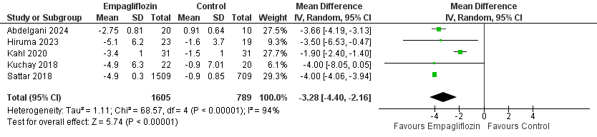
Fig 1. Forest plot of Liver Fat content

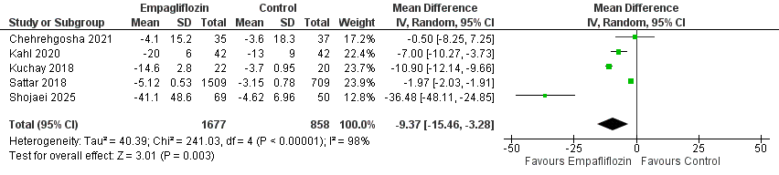
Fig 3. Forest plot of ALT

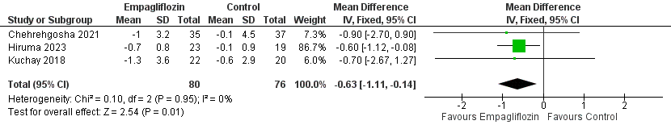
Fig 3. Forest plot of BMI

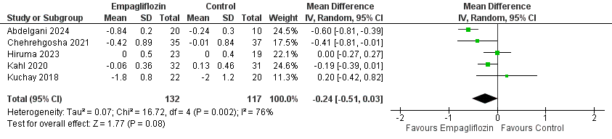
Fig 4. Forest plot of HbA1c

